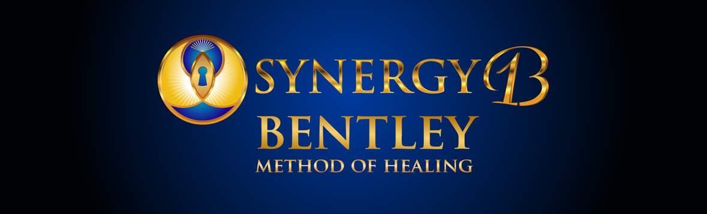

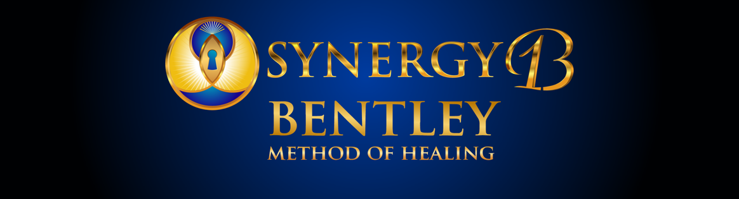

THREE DAY METAPHYSICAL SUMMER RETREAT!!!
First of its kind, guided, in-depth, hands-on experience.

Day 1. Learn how to perform a successful remote session, in a step-by-step guided sequence. Learn how to clear yourself, clear your mind, clear your emotional field, clear rooms, ground your foundation, and raise the rooms resonance creating angelic portals.
Creating a space for a clear connection to Creator, to get the guided answers you need.

“I teach you how to make thousands, by transforming lives, with your own unique gifts,
through my proven step by step methods in live & remote healing sessions.”

Day 2. Learn How To Remove Imbalancing Energy Signatures, Call in Angels, Correct Metaphysical Categories, Remove Emotional Engrams, Clear Bio-Chemical Insufficiencies, Restore Holograms, & Remove Obstructions Limiting 100% Full Physical Expression Of LIFE!
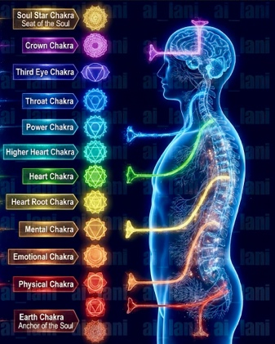
Day 3. Learn The Intricacies Of The 13 SYNERGY SITES/ SHELLS And How They Govern Every Aspect Of Our Lives! Then It’s Time To Have Fun, Play, Interact, & Practice! We Will Have 6 Tables +, Mannequins, & Wall Charts To Utilize As We Work On Each Other, Give Each Other Valuable Feedback, While Frequently Switching Partners.

“If you’re not having fun, you’re not doing it right.”

MY OFFER TO YOU, TO OVER DELIVER

WHAT YOU GET BY ATTENDING:

1. YOU RECEIVE A MASTERY LEVEL 1 CERTIFICATION IN THE BENTLEY METHOD OF HEALING, WITH THE OPTION TO BE PLACED ON MY WEBSITE AS A CERTIFIED PRACTITIONER, LISTING YOUR UNIQUE TALENTS, CREDENTIALS, CERTIFICATIONS, AND YOUR DESIRED CONTACT INFORMATION.

2. DETAILED STEP BY STEP GUIDE, WALKING YOU THROUGH EACH SECTION OF MY PROVEN REMOTE SESSIONS, WITH DETAILED EASY TO FOLLOW CHARTS AND GRAPHS.

3. A WORD DOCUMENT WITH ALL MY MOST PROFOUND & UNIQUE CATEGORIES & FINDINGS WITHIN EACH CATEGORY SO YOU CAN COPY AND PASTE DEFINITIONS AND EXPLANATIONS FOR YOUR CLIENTS.

4. ACCESS DIRECTLY TO ME WITH 4 ADDITIONAL ONLINE CLASSES AFTER OUR RETREAT TO ANSWER FURTHER QUESTIONS AS THEY ARISE.

5. INVITATION TO JOIN OUR SKOOL ACADEMY FOR CONSISTENT SUPPORT AND ACCESS TO OUR COURSES AND RECORDINGS.
This Is A Deep Dive Into The Quantum Realm Which Enhances Your Perception & Intuition, While Expanding Your Conscious Clarity & Acuity.

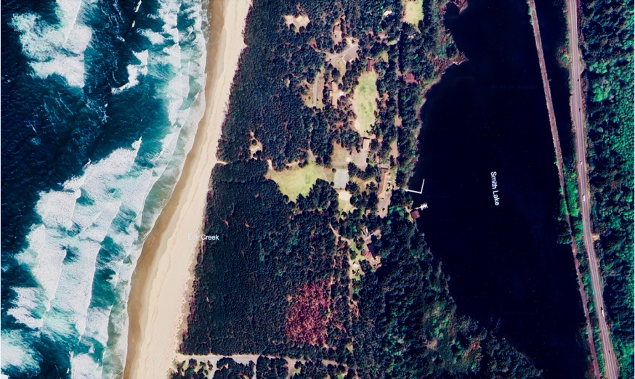
I am Excited to share, Our Summer Retreat will be held in the Most Beautiful Setting, with our deck overlooking Smith Lake with a short walk to the beach on the Pacific Ocean. We will be at the spacious and Beautiful Sherlock Lodge.

SPECIAL BONUSES:
1. Learn Thought Cycle Release, Emotional Cycle Release, Muscle/Ligament/ Tendon Reset Technique, and so many more. Learn how to awaken your Lao Gong Points (heighten sensitivity) and Balance Your Chakras.

2. Learn daily habits with checklists to protect yourself, your clients, and your loved ones.

3. Learn how to discover your unique manifestation language. Quantum Jumping with Guided Meditations to step into your highest and best version.

PLAN ON A VERY INTERACTIVE, DYNAMIC, AND EXPANSIVE LEARNING EXPERIENCE!
COME JOIN THE FUN! LIMIT TO 80 PARTICIPANTS. SEATS WILL BE GOING FAST.

RESERVE YOUR SPACE TODAY!!!
SATURDAY NIGHT CELEBRATION AT PACIFIC RESTAURANT!
SEMINAR VENUE: CAMP MAGRUDER
17450 Old Pacific Hwy
Rockaway, Oregon 97136

SEMINAR DATES: Friday, June 19th – Sunday, June 21st, 2026
SEMINAR HOURS: Friday & Saturday: 9am-5pm/ Sunday 9am-4pm
SEMINAR FEE: Early Bird Special $700/ After June 1st $800
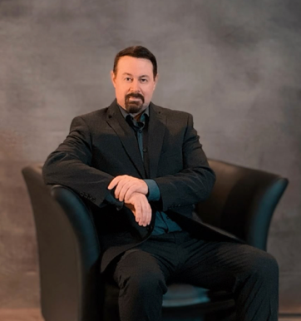
SIGN UP TODAY!: https://drjimbentley.com/#event-section

Dr. Jim Bentley is certified to teach CEW, Holographic Health, and is the founder of
The Bentley Method of Healing. His background of study includes Theta Healing, NSA, NET, BEST, Master Level in NIS, taking the 100 hour course in Applied Kinesiology 3 times to deepen his understanding and connection to the human condition. In addition, he is a Black Belt and Full Senior Instructor certified to teach Wing Chun, Lee Jun Fan Gung Fu, and Jeet Kune Do, Filipino Martial Arts, Muay Thai, and Datu Kelly Worden’s NSI. He has studied Qigong and Meditation as it applies to the practicality of combat, balance, and human efficiency. He is the author of Wing Chun The Evolutionary Science of Self Defense, Combat, and Human Performance. He also studied under world renowned Jesus Scholar Dr. Marcus Borg diving into the intricacies between Supernatural Theism, Panentheism, and Pantheism.

